# Quote of the day

Contents

## **Requirements ------------------------------------------------------------------------------- 1**

## Design ----------------------------------------------------------------------------------------- 2

## Technology Stack ---------------------------------------------------------------------------3

## Database design ----------------------------------------------------------------------------3

## Screens ----------------------------------------------------------------------------------------4

## Reference links -----------------------------------------------------------------------------5

# Requirements

1. User should be able to login with Google login
2. App should maintain user profile and should also provide logout option
3. App should quote of the day notification at 6 am or at specific time
4. App should show all the quotes in given date range
5. App should provide download quote image option
6. User should be able to share the quote of the image via whatsapp etc.
7. App should stream some motivational videos, no download option
8. App should show notification of yesterday’s quote if not notified yet because of internet unavailability.
9. App should show the piled notifications if in case not swiped out by user.

# Design

 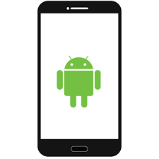

**GAE**

  

**Google Cloud Storage Bucket Google Cloud Data store Android Devices with app**

Quote of the day is an application providing daily dose of motivation to users. User can customize the schedule daily notification. User can download the quote and can also share this quote over the sharing app like whatsapp. User can also filter the notification based on the selected date range. This app also supports streaming of video files from the server.

Here, we are implementing the backend server with Google app engine which will fetch and push the quote to android devices. At the time of sending notifications, it will add the entry to the data store database. While filtering quotes in given date range, data will be fetched from the data store database. For supporting the feature of streaming the videos, app engine will stream the videos stored in Google cloud storage buckets.

# Technology Stack

1. Git
2. Android studio
3. Google cloud app engine
4. Google cloud storage bucket
5. Google cloud datastore

# Database design

## 1. Quotes database

|  |  |  |  |
| --- | --- | --- | --- |
| Date | QuoteURL | QuoteText | Author |
| 2/6/18 | https://theysaidso.com/quote/image/qU1jon5EZodrqiCdXv5GwQeF/768307 | Text | ABC |

# Screens

1. Login screen with logo & Home screen

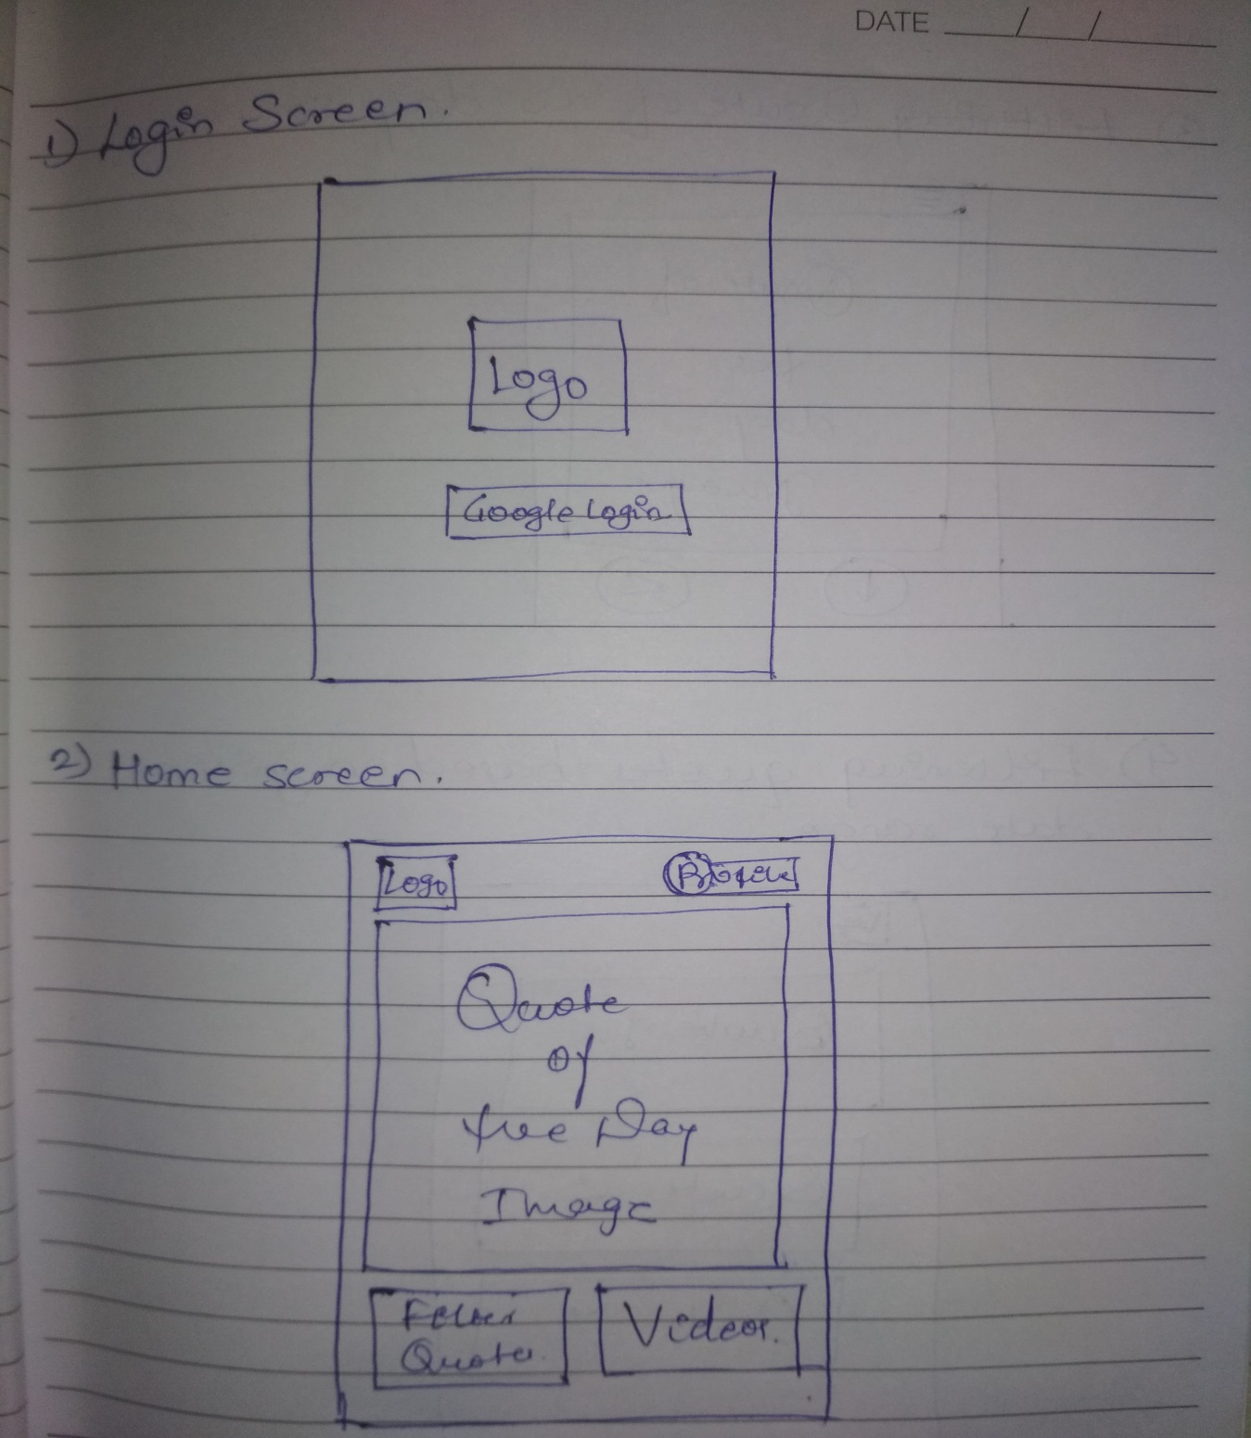

1. Quote image screen with download and share option & Date filtered quotes screen

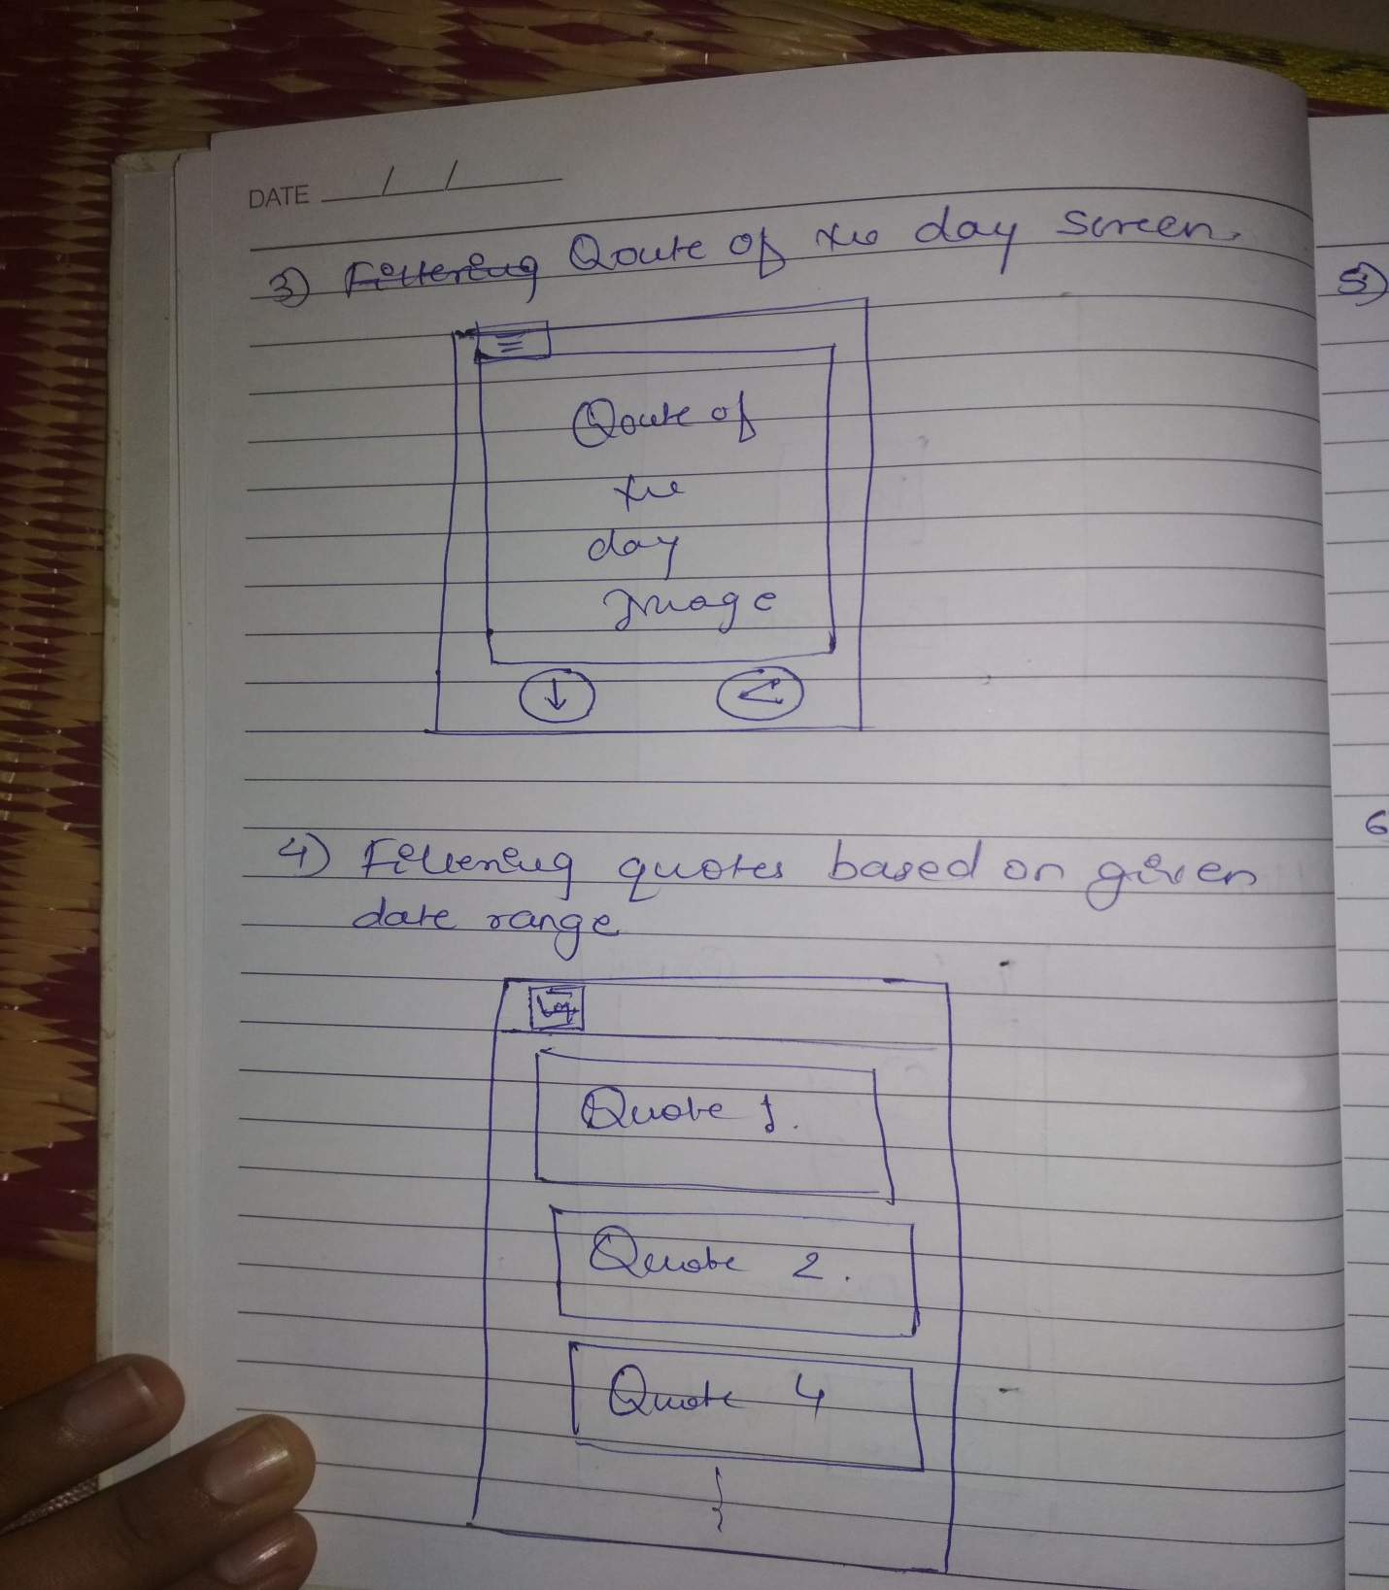

1. Video library & actual video streaming screen

